1-General Data & Utility APIs

🗂️ What Are General Data & Utility APIs?
# Source: AI Source: Provided by: [Data Path: Persons Table -> ID Column: 1, Name_En Column: Motasem Essam] -> From: [ChatGPT] on [1/19/2026]
General Data & Utility APIs are APIs that provide useful basic or widely applicable data and helper services to enhance other apps or websites. They don’t belong to a specific niche like weather, payments, or maps — instead, they provide general-purpose data or functionality.

✅ Common Uses of General Utility APIs:
# Source: AI Source: Provided by: [Data Path: Persons Table -> ID Column: 1, Name_En Column: Motasem Essam] -> From: [ChatGPT] on [1/19/2026]
- Looking up IP addresses or country details
- Getting random user or image data for testing
- Sending simple requests to automate tasks
- Validating emails, phone numbers, or domains
- Converting currencies or units

🧩 Examples of General Data & Utility APIs
# Source: AI Source: Provided by: [Data Path: Persons Table -> ID Column: 1, Name_En Column: Motasem Essam] -> From: [ChatGPT] on [1/19/2026]
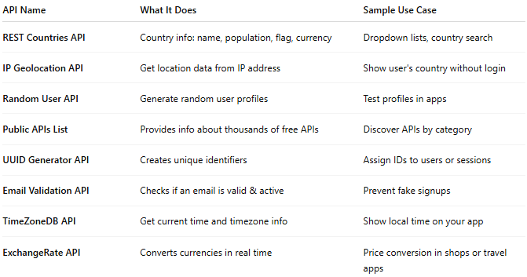

API Name | What It Does | Sample Use Case
REST Countries API | Country info: name, population, flag, currency | Dropdown lists, country search
IP Geolocation API | Get location data from IP address | Show user's country without login
Random User API | Generate random user profiles | Test profiles in apps
Public APIs List | Provides info about thousands of free APIs | Discover APIs by category
UUID Generator API | Creates unique identifiers | Assign IDs to users or sessions
Email Validation API | Checks if an email is valid & active | Prevent fake signups
TimeZoneDB API | Get current time and timezone info | Show local time on your app
ExchangeRate API | Converts currencies in real time | Price conversion in shops or travel apps

📤 Example: IP Geolocation API (Free)
# Source: AI Source: Provided by: [Data Path: Persons Table -> ID Column: 1, Name_En Column: Motasem Essam] -> From: [ChatGPT] on [1/19/2026]
Request:

GET https://ipapi.co/8.8.8.8/json/

Response:
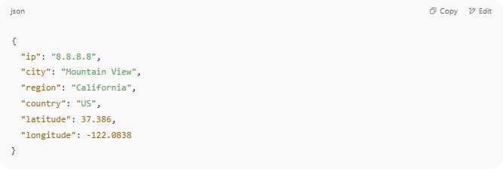
{
"ip": "8.8.8.8",
"city": "Mountain View",
"region": "California",
"country": "US",
"latitude": 37.386,
"longitude": -122.0838
}

🛠️ Why Use Utility APIs?
# Source: AI Source: Provided by: [Data Path: Persons Table -> ID Column: 1, Name_En Column: Motasem Essam] -> From: [ChatGPT] on [1/19/2026]
- Saves time: No need to build common tools from scratch
- Improves UX: Auto-fills country, timezone, etc.
- Easy to integrate: Usually simple endpoints using JSON over REST
- Many are free or have free tiers

